

**REGISTRATION NO: 2023-BS-AI-058**

**SUBMITTED BY: Maham Nisar**

**SUBMITTED TO: Ms. Irsha Qureshi**

**DEPARTMENT: Artificial Intelligence**

**SECTION: A**

**LAB TASK 03**

**1. Single-Dimensional Array**

**Example 1:Initializing and displaying elements of an array.**

#include <iostream>

using namespace std;

int main() {

int arr[5] = {10, 20, 30, 40, 50};

for (int i = 0; i < 5; i++) {

cout << "Element " << i << ": " << arr[i] << endl;

}

return 0;

}

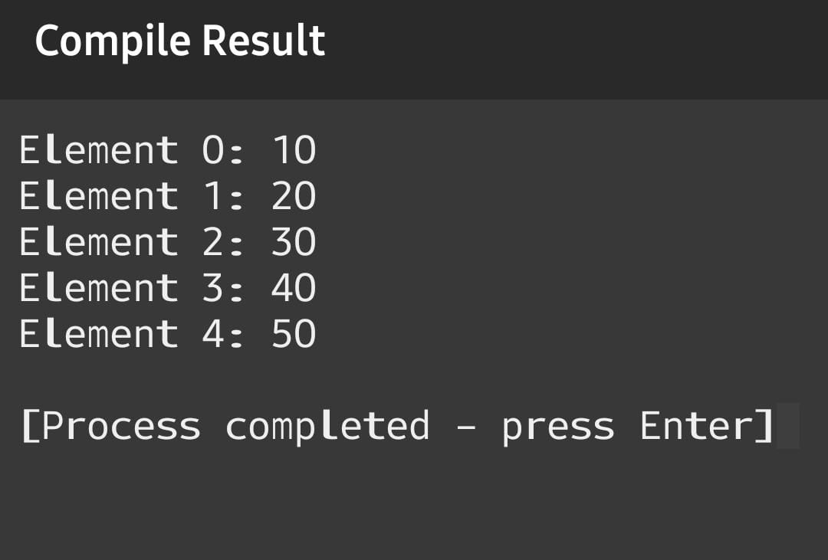

**2. Multi-Dimensional Array**

**Example 2: Initializing and displaying elements of a 2D array.**

#include <iostream>

using namespace std;

int main() {

int arr[2][3] = {{1, 2, 3}, {4, 5, 6}};

for (int i = 0; i < 2; i++) {

for (int j = 0; j < 3; j++) {

cout << "Element [" << i << "][" << j << "]: " << arr[i][j] << endl;

}

}

return 0;

}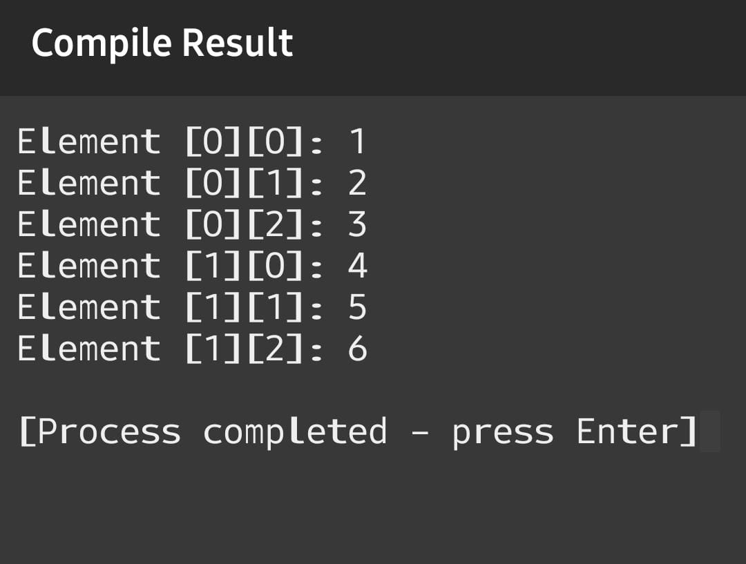

**3. Vector**

**Example 3: Creating a vector, adding elements, and displaying them.**

#include <iostream>

#include <vector>

using namespace std;

int main() {

vector<int> vec;

vec.push_back(10);

vec.push_back(20);

vec.push_back(30);

for (int i = 0; i < vec.size(); i++) {

cout << "Element " << i << ": " << vec[i] << endl;

}

return 0;

}

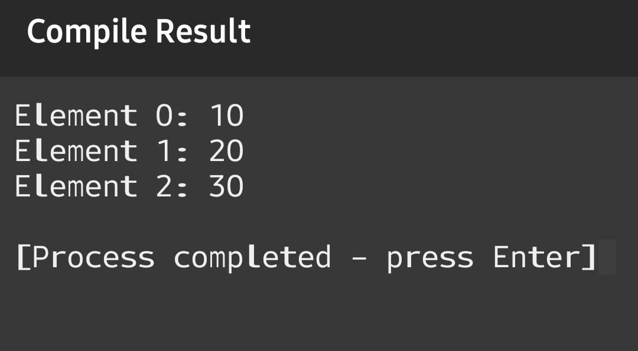

**4. Single-Dimensional Array: Sum of Elements**

**Example 4: Calculating the sum of elements in an array.**

#include <iostream>

using namespace std;

int main() {

int arr[5] = {1, 2, 3, 4, 5};

int sum = 0;

for (int i = 0; i < 5; i++) {

sum += arr[i];

}

cout << "Sum of elements: " << sum << endl;

return 0;

}

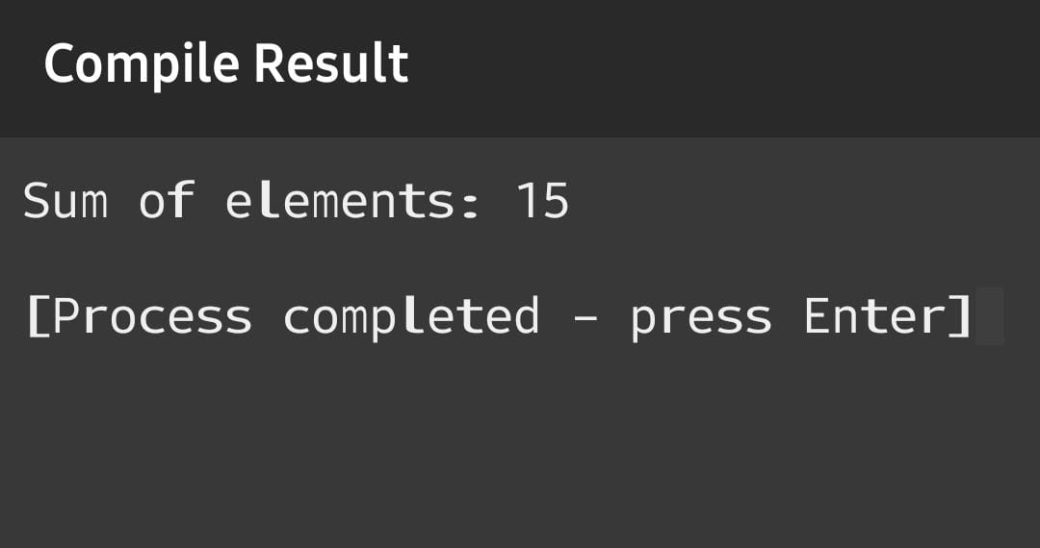

**5. Multi-Dimensional Array: Matrix Addition**

**Example 5: Performing addition of two matrices.**

#include <iostream>

using namespace std;

int main() {

int A[2][2] = {{1, 2}, {3, 4}};

int B[2][2] = {{5, 6}, {7, 8}};

int C[2][2];

for (int i = 0; i < 2; i++) {

for (int j = 0; j < 2; j++) {

C[i][j] = A[i][j] + B[i][j];

cout << "Element [" << i << "][" << j << "]: " << C[i][j] << endl;

}

}

return 0;

}

